Object Comparison
A Conceptual Overview

General Notes
Comparing two objects for equivalence is a relatively common task during test validation. For example, you might test whether a type follows the rules that are required by a particular serializer by saving and loading the object and comparing the two. In a deep object comparison, all the properties and their sub-properties are compared repeatedly until primitives are reached. The .NET Framework provides mechanisms to perform deep comparisons but requires the types to implement part of the comparison logic (IComparable, .Equals). However some types do not use these mechanisms. This API provides a mechanism to perform a deep comparison of two objects by using reflection. It also allows specifying a custom object comparison algorithm to enable such scenarios as ordered/unordered, case sensitive/insensitive, exact/non-exact comparisons.
In regression testing it is a common technique to employ some kind of baseline files with verified results and use them as oracles during test runtime. Contents of those files are somehow compared to actual results of test cases. To enable the described scenario this API provides a mechanism to persist objects into a custom file format or database for manual verification and future use. It also provides a mechanism to restore those objects and compare their states with the states of actual objects returned from the system under test.

TestApi Object Comparison
TestApi provides an API to create compare operations. The API separates the comparison operation into two parts:
- ObjectGraphFactory: Builds an intermediate representation from the object that describes what needs to be compared and attaches custom comparison strategies in order to override the default comparison behavior.
- ObjectGraphComparer: Uses a reusable compare mechanism to compare the intermediate representations of the objects, generated by the factory.
- ObjectGraphCodec: Serializes/encodes and deserializes/decodes the intermediate representation of an object graph in a data format a user defines.
- ObjectGraphComparisonStrategy: Defines a custom comparison algorithm for an object graph node.
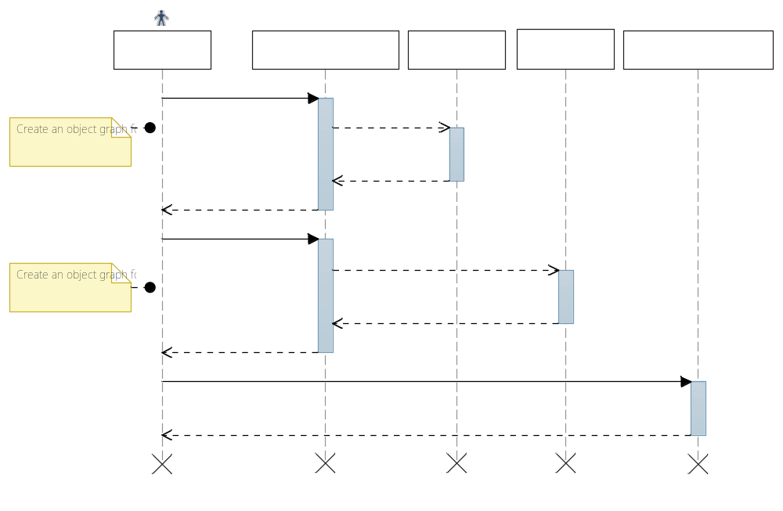
Fig. 1. Comparing two object graphs

Example #1
This example demonstrates how to use the object comparer to compare two objects. Assuming we have the following simple class…

class Person
{
public Person(string name)
{
Name = name;
Children = new Collection<Person>();
}
public string Name { get; set; }
public Collection<Person> Children { get; private set; }
}

… we can compare two objects using the following code:

Person p1 = new Person("John");
p1.Children.Add(new Person("Peter"));
p1.Children.Add(new Person("Mary"));

Person p2 = new Person("John");
p2.Children.Add(new Person("Peter"));

// Perform the compare operation
ObjectGraphFactory factory = new PublicPropertyObjectGraphFactory();
GraphNode p1Graph = factory.CreateObjectGraph(p1);
GraphNode p2Graph = factory.CreateObjectGraph(p2);
ObjectGraphComparer comparer = new ObjectGraphComparer();
Console.WriteLine(
"Objects p1 and p2 {0}",
comparer.Compare(p1Graph, p2Graph) ? "match!" : "do NOT match!");

Execution of this code produces the following output:

Objects p1 and p2 do NOT match!

Example #2
The following example demonstrates how to obtain the details of where the two objects do not match.

Person p1 = new Person("John");
p1.Children.Add(new Person("Peter"));
p1.Children.Add(new Person("Mary"));

Person p2 = new Person("John");
p2.Children.Add(new Person("Peter"));

// Perform the compare operation
ObjectGraphFactory factory = new PublicPropertyObjectGraphFactory();
GraphNode p1Graph = factory.CreateObjectGraph(p1);
GraphNode p2Graph = factory.CreateObjectGraph(p2);
ObjectGraphComparer comparer = new ObjectGraphComparer();
IEnumerable<ObjectComparisonMismatch> m12 = new List<ObjectComparisonMismatch>();
Console.WriteLine(
"Objects p1 and p2 {0}",
comparer.Compare(p1Graph, p2Graph, out m12) ? "match!" : "do NOT match!");

foreach (ObjectComparisonMismatch m in m12)
{
Console.WriteLine(
"Nodes '{0}' and '{1}' do not match. Mismatch message: '{2}'",
m.LeftObjectNode != null ? m.LeftObjectNode.Name : "null",
m.RightObjectNode != null ? m.LeftObjectNode.Name : "null",
m.MismatchType);
}

Execution of this code produces the following output:

Objects p1 and p2 do NOT match!
Nodes 'Children' and 'Children' do not match. Mismatch message: 'RightNodeHasFewerChildren'
Nodes 'IEnumerable1' and 'null' do not match. Mismatch message: 'MissingRightNode'
Nodes 'Children' and 'null' do not match. Mismatch message: 'MissingRightNode'
Nodes 'Count' and 'null' do not match. Mismatch message: 'MissingRightNode'
Nodes 'Name' and 'null' do not match. Mismatch message: 'MissingRightNode'
Nodes 'Count' and 'Count' do not match. Mismatch message: 'ObjectValuesDoNotMatch'

Example #3
The following example demonstrates how to create a custom object graph factory which determines which nodes in the object graph to compare.
For simplicity, we construct a factory that disregards any children.

class SimpleObjectGraphFactory : ObjectGraphFactory
{
public override GraphNode CreateObjectGraph(
object o, ObjectGraphFactoryMap factoryMap = null)
{
// Build the object graph with nodes that need to be compared.
// in this particular case, we only pick up the object itself
GraphNode node = new GraphNode();
node.Name = "PersonObject";
node.ObjectValue = (o as Person).Name;

return node;
}
}

Then, we utilize the factory to generate graph representations of the two object we want to compare.

Person p1 = new Person("John");
p1.Children.Add(new Person("Peter"));
p1.Children.Add(new Person("Mary"));

Person p2 = new Person("John");
p2.Children.Add(new Person("Peter"));

ObjectGraphFactory factory = new SimpleObjectGraphFactory();
GraphNode p1Graph = factory.CreateObjectGraph(p1);
GraphNode p2Graph = factory.CreateObjectGraph(p2);
ObjectGraphComparer comparer = new ObjectGraphComparer();
Console.WriteLine(
"Objects p1 and p2 {0}",
comparer.Compare(p1Graph, p2Graph) ? "match!" : "do NOT match!");

Execution of this code produces the following output…

Objects p1 and p2 match!

… which is the expected result, given the fact that our simple factory completely disregards the Children of Person.

Example #4
The following example demonstrates how to store the object graph constructed by an object factory into an XML file for a future use.

Person p1 = new Person("John");
p1.Children.Add(new Person("Peter"));
p1.Children.Add(new Person("Mary"));

ObjectGraphFactory factory = new PublicPropertyObjectGraphFactory();
GraphNode p1Graph = factory.CreateObjectGraph(p1);

// Encode the object graph into XML using the codec
MemoryStream stream = new MemoryStream();
XmlObjectGraphCodec codec = new XmlObjectGraphCodec();
codec.EncodeObjectGraph(p1Graph, stream);

// Print the encoded representation to the console
stream.Position = 0;
using (var reader = new StreamReader(stream))
{
Console.WriteLine(reader.ReadToEnd());
}

Execution of this code produces the following output.

<?xml version="1.0" encoding="utf-8"?>
<RootObject>
<Name>John</Name>
<Children>
<Count>2</Count>
<IEnumerable0>
<Name>Peter</Name>
<Children>
<Count>0</Count>
</Children>
</IEnumerable0>
<IEnumerable1>
<Name>Mary</Name>
<Children>
<Count>0</Count>
</Children>
</IEnumerable1>
</Children>
</RootObject>

Example #5
The following example demonstrates how to use encoded representation of an object graph to compare it with an actual object graph in memory. That is, the encoded object graph serves as an oracle to judge whether a newly created object graph is correct (equals to the oracle).

Person p2 = new Person("John");
p2.Children.Add(new Person("Peter"));

ObjectGraphFactory factory = new PublicPropertyObjectGraphFactory();
GraphNode p2Graph = factory.CreateObjectGraph(p2);

// Encode and decode the actual object graph to simulate a possible
// data loss occurred during object encoding
MemoryStream roundtrip = new MemoryStream();
XmlObjectGraphCodec codec = new XmlObjectGraphCodec();
codec.EncodeObjectGraph(p2Graph, roundtrip);
GraphNode actual = codec.DecodeObjectGraph(roundtrip);

// Read the expected object graph from a baseline file prepared beforehand
GraphNode expected;
using (var baseline = new FileStream(“c:\\MyBaseline.xml”, FileMode.Open))
{
expected = codec.DecodeObjectGraph(baseline);
}

// Compare actual and expected graph nodes
var comparer = new ObjectGraphComparer();
var result = comparer.Compare(expected, actual);

